Lab 4 – Question 4

1. $x_{1}^{'}=2x_{1}+x_{2}$; $x_{2}^{'}=x_{1}+3x_{2}$ a) 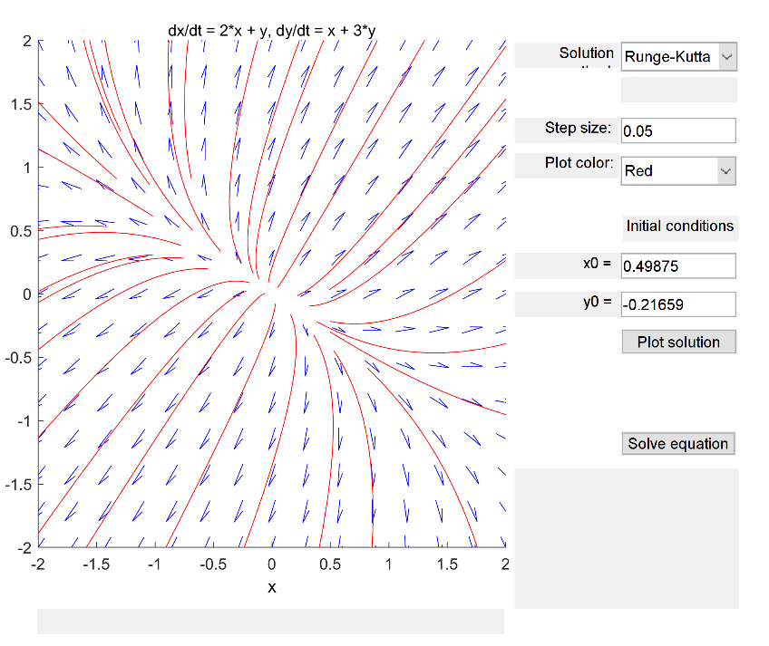  
   b) Unstable, nodal source.  
   c) $λ=\frac{5±\sqrt{5}}{2}$. The eigenvalues are both positive and distinct, therefore the equilibrium is an unstable nodal source.
2. ; a) Graphical user interface, chart

   Description automatically generated  
   b) Asymptotically stable, nodal sink.  
   c) $λ=\frac{-5±\sqrt{5}}{2}$. The eigenvalues are both negative and distinct, therefore the equilibrium is a stable nodal sink.
3. ;   
   a) Graphical user interface, chart

   Description automatically generated  
   b) Unstable, saddle point.  
   c) . The eigenvalues have opposing signs, therefore the equilibrium is a saddle point and is unstable.
4. ;   
   a) Graphical user interface, chart

   Description automatically generated  
   b) Unstable, saddle point.  
   c). The eigenvalues have opposing signs, therefore the equilibrium is a saddle point and is unstable.
5. ;   
   a) Chart

   Description automatically generated  
   b) Asymptotically stable, spiral sink, counterclockwise movement.  
   c) $λ=-\frac{1}{2}±\frac{i\sqrt{3}}{2}$. We have complex eigenvalues with negative real parts, therefore the equilibrium is a stable spiral sink.
6. ;   
   a) Graphical user interface, chart

   Description automatically generated  
   b) Unstable, spiral source, clockwise movement.  
   c) $λ=\frac{1}{2}±\frac{i\sqrt{3}}{2}$. We have complex eigenvalues with positive real parts, therefore the equilibrium is an unstable spiral source.
7. ;   
   a) Graphical user interface

   Description automatically generated  
   b) Stable, spiral center, clockwise movement.  
   c) . We have complex eigenvalues with real parts equal to 0, therefore the equilibrium is a stable spiral center.
8. ;   
   a) Chart

   Description automatically generated with medium confidence  
   b) Stable, spiral center, counterclockwise movement.  
   c) . We have complex eigenvalues with real parts equal to 0, therefore the equilibrium is a stable spiral center.
9. ;   
   a) Graphical user interface, chart, scatter chart

   Description automatically generated  
   b) Stable, spiral center, clockwise movement.  
   c). We have complex eigenvalues with real parts equal to 0, therefore the equilibrium is a stable spiral center.
10. ;   
    a) Graphical user interface

    Description automatically generated with medium confidence  
    b) Stable, spiral center, counterclockwise movement.  
    c). We have complex eigenvalues with real parts equal to 0, therefore the equilibrium is a stable spiral center.